**Data Models and Types of data models**

Data model is the underlying structure of a database which is a collection of conceptual tools for describing data, data relationships, data semantics, and consistency constraints.

The three data models that are used for database management are

1.Relational Data Model

2.Network Data Model

3.Hierarchical Data Model

**The Relational Data Model**:

In Relational Data Model, the data is organized into tables i.e. rows and columns. These tables are called relations. A row in a table represents a relationship among a set of values.

In relational model, the relationships among data are represented by a collection of tables.

Let us see how a sample database can be represented in relational form. Our sample database consists of three tables(relations) here. They are: Suppliers, Items and Shipments.

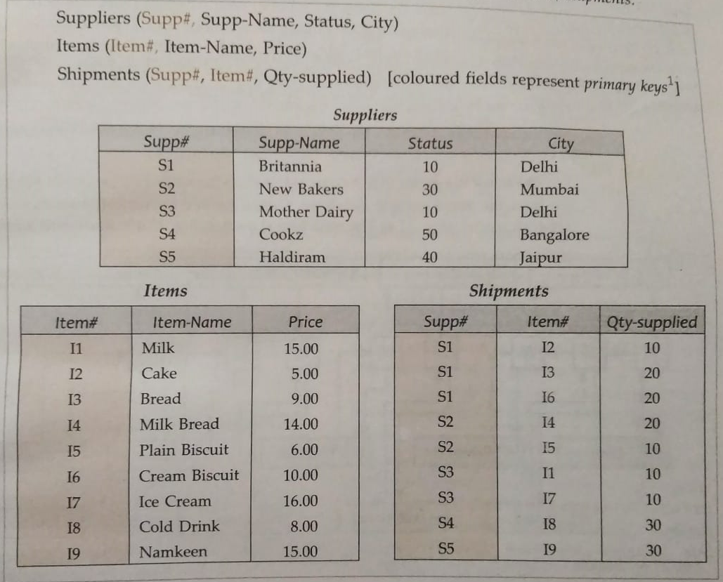

Here each supplier has a unique supplier number, exactly one name, status value and location. In items table, we have Item number, name and price.

Rows of relations are referred to as tuples and the columns are referred to as attributes.

The relational model is based on a collection of tables(relations). The user of the relational database system may query these tables, insert new tuples, delete tuples and modify tuples.

**The network data model:**

The network model differs from the relational model in that data is represented by collection of records and relationships among data are represented by links.

In a network database, the collection of records are connected to one another by means of links. A record is a collection of fields(attributes), each of which contains only one data value.

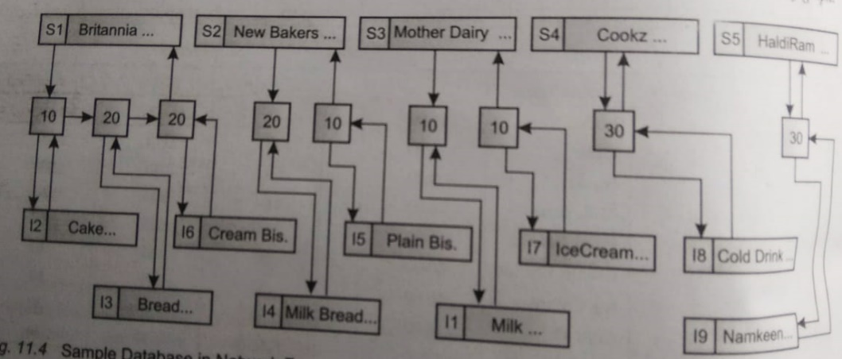

In the shipments table the supplier s1 supplies three items I2, I3, I6 in the quantities 10,20 and 20 respectively. The operations that can be performed on a network database are find, insert delete and modify.

The Hierarchical Data Model

In the network model, the data is represented by collection of records and relationships among data and are represented by links. This is same for hierarchical model but the only difference is that in the hierarchical model, records are organized as trees means this model represents relationship among its records through parent child relationships.

